### Current Activities

Hursley site remains closed, apart from a small number of essential staff, so we have not been able to gain access to the museum since early March. It seems unlikely the situation will change this year.

This has not meant that work has dried up; indeed there have been a lot more activities from home. We have had quite a few donations delivered to home addresses and subsequently dropped off at Hursley with a ‘permitted’ member of staff taking them inside. That has also allowed us to retrieve items so we can carry on with off-site activities. We’ve also introduced curator Zoom meetings every couple of weeks. Here are some of the highlights since May:

* Peter Short has joined the IBM Austria retiree club. Eligibility comes from 2.1/2 years working on assignment as a Customer Engineer in Salzburg in the early 70s. This allowed a country-wide appeal for donations, with several ex-CEs sending amongst other things:
  + A fishing tackle box full of spare parts mainly for card punch and unit record machines, all now catalogued on the website from home
  + Daisy wheel typewriter, DOA but repaired by replacing power supply capacitors
  + Selectric typewriter
  + 3277 keyboard and other miscellaneous parts
* 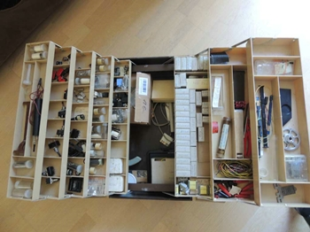 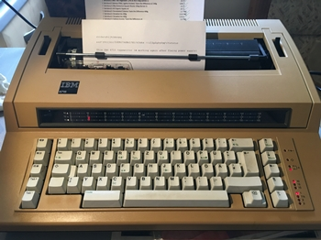  
  CE Parts Box 6715 Daisy Wheel Typewriter
* Another attempt by the donor to get the 129 card punch / verifier across from the Netherlands failed, the trip cancelled at the last minute due to the virus restrictions.
* We have been promised a CE tool that none of us can identify. It consists of a small carry case containing a cassette recorder and a couple of logic cards.
* With Hursley closed, a small team has been doing essential site maintenance. They have discovered a signal generator and power supplies that we believe are from a hardware test cell, perhaps used during drop testing. These are being retrieved to the museum for us.
* Many other donations received or promised, a summary can be seen on the museum website news page <https://slx-online.biz/hursley/news.asp> .

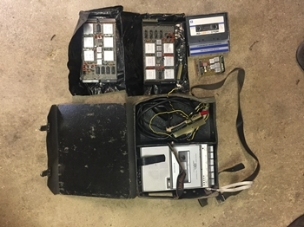 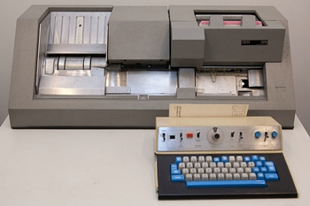   
Unidentified CE Tool 129 Buffered Card Punch / Verifier

* 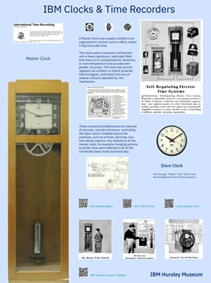For some time we have been thinking about how best to enhance our displays. The consensus is to produce large panels to stand behind, above or to the side of artefacts where appropriate.   
    
    
  We have a clock and a calculator on display in a communal area of the Hursley site, so we’re starting there as a ‘proof of concept and process’.   
    
    
  We decided on the ‘upside down roller blind’ approach rather than big panels so they can be easily moved if necessary. Peter S has produced the artwork at 2M x 1.5M for the clock with the help of fellow curators. Lab management is supportive and looking at how we might get this produced and pay for it.   
    
    
  The actual clock will stand in front of the full size image, which is included so the panel can be used elsewhere stand-alone if necessary.
* Prior to the closedown in March we initiated a small study with Hursley to explore more ways to generate new interest in the museum, increase our own cooperation with the Labs and provide a mutual benefit for the museum and students participating in [IBM’s Extreme Blue programme](https://www.ibm.com/employment/extremeblue/).  
    
  One possibility is the development of a tablet application to serve as a museum visitor log with the ability to capture compliments, comments and suggestions. Such an app could also serve as a way for visitors to contact the curators directly when not on site and numerous other benefits.   
    
  The study is at the requirements gathering stage, which we hope to continue once the site reopens. It will be proposed to IBM’s Extreme Blue coordinators in due course.